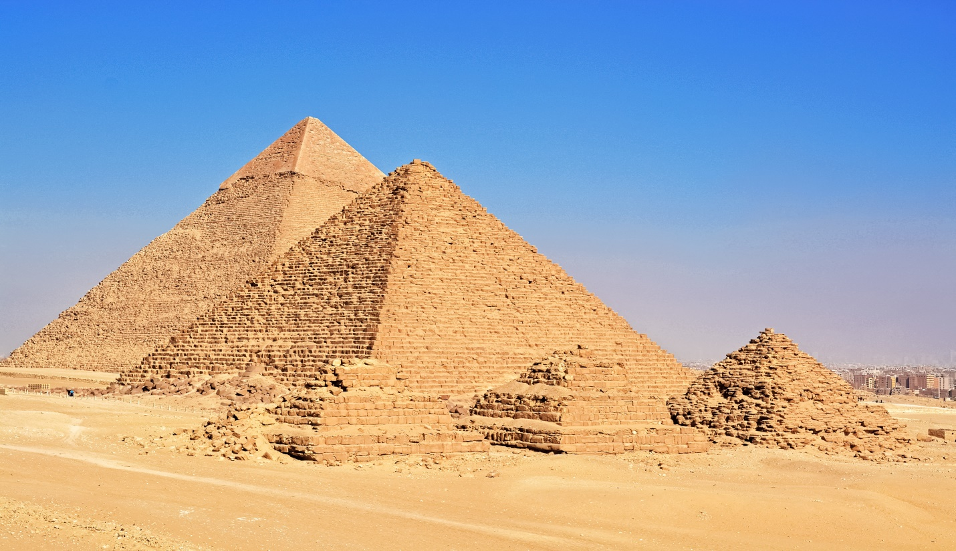
What You Never Knew About Stone Masonry
How on earth did ancient stonemasons carve out massive stone blocks from distant quarries, some weighing more than one thousand tons, then fit them together with perfect precision and astronomical accuracy?
In the city of Cusco, Peru lies the walled complex of an irregularly shaped giant jigsaw block, some stones weighing more than 150 tons at an elevation of 12,000 ft high in the Andes Mountains. The stones are spaced so closely a single sheet of paper will not fit between them. This technical achievement still puzzles modern scientists.
It’s predicted that the art and craft of stone masonry is over 50,000 years old.
As skills, tools, techniques and equipment advanced, stonemasons began creating structures hugely important to nations and civilisations. Yet do we know for sure that even greater equipment or some far superior abilities didn’t exist in these ancient times that we are not fully aware of today ?
Some of stonemasonry’s famous triumphs: The great pyramids of Egypt. The Sphinx. All around the world, ancient civilizations developed stonemasonry. Greeks built temples, Central Americans made their beautiful step pyramids. Persians built palaces, and Romans created their coliseum and other marvelous structures that still exist.
In medieval times, stone was frequently used to build castles, bridges, cathedrals and other structures that were designed to stand the test of time. Stone gave masons the opportunity to build much higher and support much heavier superstructures. During the Renaissance, stonemasonry reached new heights.
Italy shone with works like the Fountain of Neptune, the Cathedral of Santa Maria del Fiore and the Laurentian Library in Florence. Yet even with all its splendor, Italy could never hold the same ancient roots and history that the Masons incapsulated at Axum, Ethiopia. Stone masons crafted for the gods, and for the Most High God.
The Long Life of Stone Masonry
Stone Masonry has a useful life of a now understood 50,000 years in many cases and sometimes even more than that.
Also, time goes on and these buildings still stand, and may well still stand long after our current concrete jungle deteriorates.
Masonry was and is still an offering and a sacrifice. A stone mason is surrounded by deadly environments, dangerous tools, chemical residue, and endless dust. Any one of these things could kill a mason in a second, or over a long period of time and it takes endless awareness and caution to survive the day or a career, in Stone Masonry.
When you think about it, many of the sites that people travel all around the world to visit have a team of stonemasons to thank!
Scientists are baffled, and have called out to Egypt to have a “do Over” in a desperate attempt to recount the years and age of these ancient creations, cities and, “ruins”. We clearly underestimated these by tens of thousands of years in age. To these requests, many new digging and research applications to many nations have been denied. These ancient mysteries deserve much more thought than just science alone can offer.

Tools & Techniques of Stone Masonry
Until 150 years ago, the tools and techniques used to work stone had remained largely unchanged for 5000 years! A piece of stone was simply extracted from the ground and shaped to whatever was required using a mallet or hammer and chisels. The advent of steam and then electricity meant that machines could be produced that helped the cutting and sometimes shaping of the stones.
Our workshop and stone masons’ inventory still includes the same chisels, mallets and other hand tools that would have been used by generations of masons before us.
Unfortunately, the ancient skills that built some of the world’s most magnificent edifices are disappearing. With modern building practices and the varying materials available for use, the craft is in short supply. The last half of the twentieth century saw such a huge change in technology, society, and the economy that it has put the traditional methods of building, craftsmanship, and training in jeopardy.
Masonry can be as simple, or complex as the stonemason decides upon. A stonemason uses his tools to craft pieces of rock into more appealing shapes, using mortar to form structures. It is exciting to be part of a tradition that goes back more than 6,000 years!
We don’t have a ring on our finger powered by angels, and we don’t have giants to assist us with our daily chores, we don’t have the blue prints for equipment and tools that can create gigantic cubes of rock so perfect no man could have made them alone.
We may not believe in angels or magic or giants, yet masonry tells a tale of all these things, and more, and has held the secrets of the ancients for longer than you and I will ever actually know.

