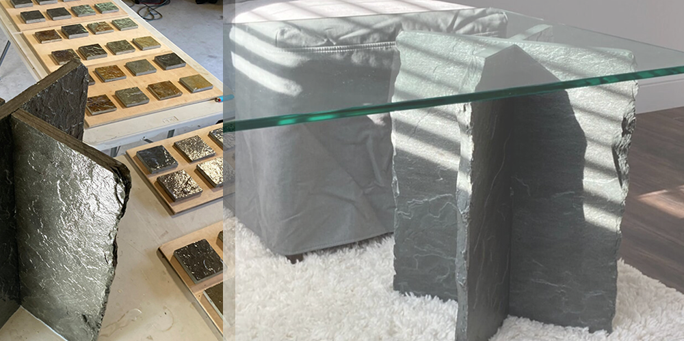

NATURAL STONE FURNITURE
A Statement of Luxury and Versatility

Natural stone furniture is timeless with a simplicity of style.
The versatility of natural stone helps create innovative furniture pieces for all tastes. Natural stone can be incorporated into tables, benches, and chairs. Marble, slate, and onyx can be used to produce furniture.
The aesthetic and functional benefits provided by natural stone make it a perfect element for various decoration purposes. It is durable, sustainable, and can be incorporated into different interior design applications.
Natural Stone has become a popular material that lasts forever and represents luxury and status. Due to its versatility, it is the first choice for interior design. A reflection of nature, natural stone is perfectly imperfect, with a wide range of colors, textures and patterns.
Classy Furniture for the Outdoors
Decorating an outdoor space is a fun adventure, but can be quite challenging. This is especially true when it comes to selecting the best furniture for your patio or garden. A growing trend in outdoor furniture is to stick with natural stone materials because that is the best way to add style and also more natural space. One of the more popular materials seen throughout natural outdoor spaces is granite. Granite is tough and weatherproof and does an amazing job of complimenting the natural space around you.
The Many Advantages of Natural Stone Furniture
- Built to last like granite and marble, natural stone ensures that your garden furniture has a long life. Unlike artificial materials, natural stone does not easily break down over time. Other natural materials like metals and wood may also seem like a viable option. But keep in mind that those types of furniture show signs of aging quickly.
- Wood furniture can easily chip and scratch. Metal furniture cannot be left out year round because it is vulnerable to weather damage, like rust. But natural stone can reside in your garden year round which makes it a great permanent option for your outdoor space.
- Minimal Upkeep
When you purchase wood or metal outdoor furniture, you have to consider the amount of upkeep and work that goes into keeping it fresh looking. Wood furniture will have to be properly stained and weatherproofed because it is a more porous material. This helps to keep it from growing mold which can eat away at the wood over time. Metal furniture will have to be polished frequently to keep it from rusting and to help keep it looking new and fresh.
But, natural stone materials require minimal upkeep, thus a great choice for your outdoor garden. Reason? Materials like granite are denser and don’t hold moisture like wood does. How do you keep your stone furniture looking great? Just clean it properly!

Natural Stone Use in Architecture, Interiors and Design
Natural stone such as marble, onyx, or limestone is found in many architectural and interior design products. But why is this natural material one of the favorites in the world of design? First and foremost, natural stone is durable and highly resistant. In addition to its long-lasting characteristic, some natural stones are weather-resistant, thus commonly used in many architecture projects. For the very same reason, interior design and product design often use natural stone.
Another characteristic makes this material very popular – its unique texture and unrepeatable beauty.
Natural stone coffee tables and end tables make a powerful statement in your home since no two pieces are alike. Their unique patterns give your living room depth and warmth.
Another benefit of natural stone furniture? Longevity. You could have scratch-free furniture that lasts decades and resists any wear and tear.
Natural Stone in Office Design
Once a formal space, the modern workplace now embraces technology and optimizes employee performance. The timeless beauty of natural stone makes it an ideal choice for desktops, flooring, wall cladding, and conference room tables.
Beyond making an impression on clients, office design also impacts a company’s bottom line, effecting profitability and even employee performance.

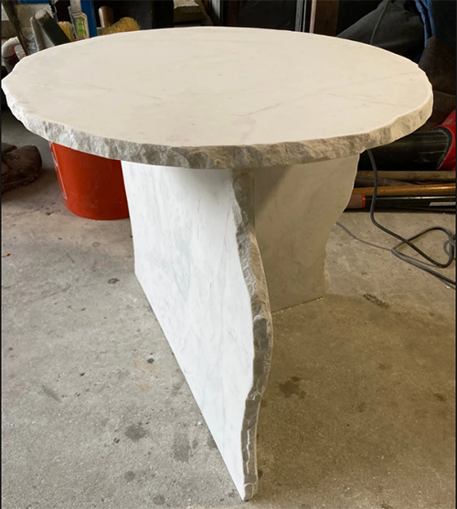
Beach Sand White Marble Table. A sculpture not just a table. A raw mineral table from pure marble, this one has a T shaped base with natural edges showing off the beautiful exposed marble.

The Rockstone Install Yourself Flat Pack
The Flat Pack style by Rockstone and More: Install yourself, self supporting, endless color and texture options, no screws or nails. Small to gigantic.
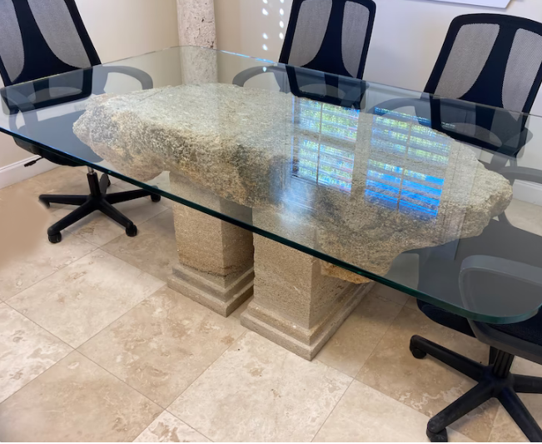
Coral Stone Home or Office Table
Hand crafted coral stone home or office table with a glass top. Made from St Augustine Coral Rock, this table style is available in many sizes and shapes based on your needs.
Sturdy, bold, stunning, this style of table will not be forgotten overnight. Enjoy hours of staring at the countless details and patterns in the stone.
.

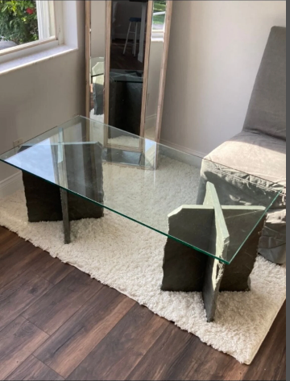
Glass Top Natural Stone Coffee Table
Coffee table made entirely from natural materials. PA Blue Rock for base legs and glass top. Hand shaped, this table slides together with no glue or screws and stands rock solid in place. Eight square foot table surface area, and 8 square feet of natural Pennsylvania Blue Stone base
Innovative Furniture
Whether you opt for a full natural stone piece or for furniture coverings made of natural stone, natural stone will always make your space look classier.
Stone Craftsmanship
Stone carving is a marriage of machinery and craftsmanship. A natural material, irregularity comes with natural stone, providing patterns within patterns millions of years in the making.
Rockstone & More Inc. does not use CNC technology for its stone design and fabrication. All of its creations are proudly handmade.
A skill but also an art, stone craftsmanship is a rare and irreplaceable skill. Though fewer in number than they were in the past, stone artisans are still working, and their skills are indispensable. Using a combination of modern machinery and ancient craftsmanship, they are plying their trade in interior design, high-end homes and commercial buildings whose owners want a distinctive touch.
For more information, contact:
Rockstone & More Inc.

