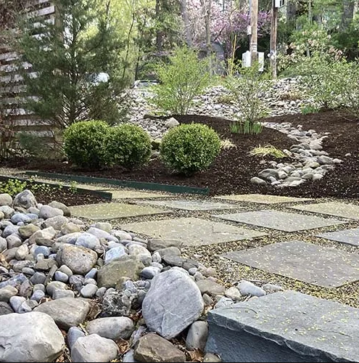
7 Reasons Landscape Architects, Contractors and Designers Love Natural Stone
Natural stone makes a statement like none other. When using natural stone in product design, one will never be the same as another, despite using the same stone collected from the same place. And that is luxury – a natural material, beautiful, durable, and unique.
Variations in natural stone’s broad range of color, pattern, and texture are visually interesting and impossible to replicate.
And, because it comes from the earth, from eco-friendly compositions, it is a natural choice.
1) VARIETY
The diversity of natural stone products encourages limitless design potential. Aesthetically, what you do with stone is as varied as your imagination. The way stone forms within the earth contributes to its varieties and creativity – something that cannot be duplicated in a laboratory or come from a mold.
The history of natural stone pavers in Mediterranean culture dates back to Roman times. Ancient civil engineers discovered a masonry system of capstones to convert muddy surfaces into stone paths helping Roman soldiers to march on.
For long-lasting beauty, use Blue Stone pavers for patios, courtyards and walkways. This handsome paver combines a subtle textured surface and generous proportions offering a strong, durable, and bold addition to any outdoor project. Oversized edge spacers create a larger joint to more closely simulate a natural stone appearance.
Florida supplier of custom fabricated high-quality stone products, Rockstone & More Inc. offers a range of flagstone, a large slate rock split up at the quarry in the Northeast where it is found. It comes in a variety of colors such as Blue, Lilac, Full Color and Lime.
Flagging is very natural in appearance and random in size and shape. Rockstone’s flagstone is perfect for large scale patios, walkways and driveways.
- Perfect for water features, boarders, tread stones, retaining walls and more.
Rockstone & More Inc. supplies fieldstone from the field and mostly above the ground. Many of these rocks have moss growing on the surface, giving off incredible colors and texture. This stone has a more rustic green and brown color and is separated into size and shape.
- Floor Tiles are ideal for any floor surface, from outdoors to indoors or fireplace finishings.
2) DURABILITY
Natural stone exhibits a durability not found in other building materials. There is an emotional connection to buildings and monuments built in stone that carries a great deal of meaning due to enduring history and a legacy of mankind through the ages.

3) GREEN ATTRIBUTES
Natural stone products like those created in granite, marble, limestone, slate and sandstone possess innate characteristics that contribute toward LEED (Leadership in Energy and Environmental Design) or LEED intended construction.
Stone is a naturally occurring material, often locally within a 500 mile radius of the project. There are no off-gases to impair indoor air quality, with exceptional durability for low maintenance and structural permanence.
Using natural stone for your projects shows that you care about the environment and consciously strive to preserve it.

4) UNIQUE
Design projects should stand out and reflect the passion, taste, and personality of the designer. Natural stone is a one-of-a-kind building material that sets you apart from others because it can’t be mimicked, manufactured, or faked.

5) VALUE-ADDED NATURAL STONE
An excellent way to maximize a project’s value is to specify an enduring, durable, and high-performance product like natural stone. When you specify stone to maximize the material’s benefits, you’ll bring your vision to life while providing owners with an environmentally friendly solution that meets their needs.
Natural stone involves longevity, ease of maintenance, permanence and stability. Utilizing natural stone is now more affordable than ever due to advanced stone quarrying and processing technology.
Development of anchoring technologies and systems make installation easier, quicker, and more secure.
Natural stone is simple to care for, has an appearance that improves with age and lasts a lifetime.
6) ABUNDANT & RICH NATURAL STONE
Unlike other building materials that have to be fabricated or produced using harsh chemicals, natural stone is abundant in quantity, bountiful in colors and designs, and eco-friendly.
For clients who want the best possible way to achieve an authentic, rich look, natural stone is the way to go.
As natural stone is extracted directly from the great outdoors, it allows for a landscape design to easily emulate nature, often creating the most serene space.
7) EASY MAINTENANCE
Natural stone can be pressure washed without consequence, whereas manufactured products would be destroyed.
For more information contact:
Rockstone & More, Inc.
Natural Stone Supplier
(561) 720-9513

